


GL GEAC interface to INFOR CSF

General ledger



Southeastern Pennsylvania Transit Authority

Authors: Bharat Vandra – Project Director, Infor
Date: March 29, 2017

Table of Contents –
2 Document Change Control 3
3 Overview 4
3.1 Current geac – gl file 6
3.1.1 Header 6
3.1.2 Detail 8
3.1.3 Trailer 10
3.2 GEAC to CSF Mapping translation 11
3.2.1 Header 11
3.2.2 Detail 11
3.3 Processing in CSF 13
4 Data / Export Overview 16
5 Technical Solution Design 21
5.1 Process Flow Design 21
5.2 File Location 22
5.3 System Configuration 23
5.3.1 File Transfer Connection 25
5.4 Schedule 25
5.5 File Channel Setup 25
5.5.1 File Channel Receiver Setup (Translation Process Flow) 26
5.5.2 File Channel Receiver Setup (Automated GL Interface Process Flow) 26
6 File Details 27

Document Change Control
Date | Version | Author | Change History
02/17/2020 | 1.0 Draft | Bharat Vandra | Initial draft version of document
02/22/2021 |  | Sujatha N | Draft version of the GL GEAC interfaces which will be imported into CSF
03/02/2021 |  | Benjamin Almazan | Updated Technical Solution Design

Overview
Currently, SEPTA has multiple vendors that provide Journal data in the GEAC format and would need to interface the files into CSF. To properly interface the files into CSF, a process flow would be needed to translate the GEAC format into the CSF format prior to placing the records into the GLTransactionInterface staging table.
Vendors will need to place the General Ledger files that needs to be interfaced in an SFTP directory as a .TXT file which then be scanned by CSF’s file Channel’s to be processed for translation to CSF format.
Below are SEPTA’s third-party vendors who will be utilizing the General Ledger Transaction interface to CSF.
Interfaced Applications | Type | Frequency
FELA GL FEEDER FILE | inbound | Monthly
TWS GL FEEDER FILE | inbound | Monthly
REVENUE GL FEEDER FILE | inbound | Monthly
NPT GL FEEDER FILE | inbound | Monthly
CLAIMS (PIP) GL FEEDER FILE | inbound | Monthly
UNION DUES GL FEEDER FILE | inbound | Monthly
PERSION COPAY FEEDER FILE | inbound | Monthly
Worker's Comp | inbound | Monthly

The interface will be following the process below:
- Read through the contents of the GL file provided and Identify the Header, Details lines, and trailer.
- Iterate through the positions of each field in the GEAC file for translation to CSF.
- Map the data from the existing file based on positions to the corresponding CSF fields
- Validate the file and add the data in correct CSF Business class in this case it is the GLTransactionInterface Business class.
- The records will be added on to the staging table via DBImport. Record validation will happen once the details have been added to CSF.
If the file validation fails, the interface will then delete the data which was entered from the file and send the error transaction list to the client in an email. (One of the checks would be to make sure the CR and DB of the batch tie out and the batch is balanced)
If the file validation is successful, and the data is added into CSF Business class GLTransactionInterface successfully, then Interface can trigger the interface action on this Business class to move the data as journals in the GL system.
Note: This interface can be triggered by
- Automatic – OR –
- Manually – OR –
- Scheduled Job to run at a pre-decided time

Field Mapping
The current GL GEAC file is as below:
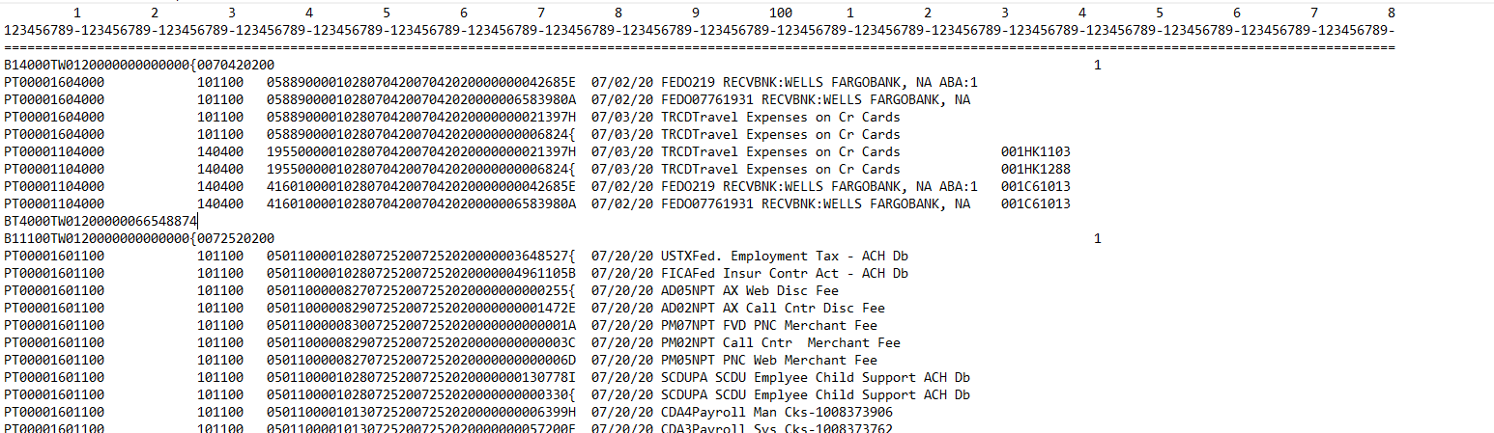
Key characteristics of the GEAC files to be imported:
- Fixed length file with a max length of 180 characters.
- Includes multiple Header, Detail and Trailer record per originating GEAC company.
- Header is defined by “BH” or “B1”
- Details are defined “PT” these are the transaction lines
- Trailer is defined by “BT”

Header
Header record start with BH or B1
B11100TW0120000000000000{0072520200

GEAC Mapping | Position | Value | Comment
Transaction code | 1-2 | B1 or BH | Part of this field can be used as Rungroup  B11100TW01
Company ID | 3-6 | 1100 | Will be saved in the FinanceDimension1 fields since CSF will have only one company
Application area | 7-8 | TW | Indicates where the Journals came from. Kindly see “Application Area” list.
Batch number | 9-10 | 01 | Default value is “01”
Data Type code | 11 | 2 | What does data type code indicate? I have to look it up in the GEAC document, but it's always 2
Batch total | 12-25 | 0000000000000{ | Will always amount to 0
Closed for Adjustment indicator | 26 | 0 | Default value is “0”
Effective date | 27-34 | 07252020

Application Area Codes
Below are the Application Area codes used in the GEAC format:

Application Area | Description
AP | Accounts Payable
AR, CR | Accounts Receivable
RV | Revenue
PA | Project Accounting
CT | Claim's PIP
RV | NPT
PR | Payroll
WI | Worker's Compensation
AG | ASI
FA, FB, FC | Fixed Asset
FE | FELA
TW | TWS (Treasury Work Station)

Detail
Detail or Transaction record starts with PT
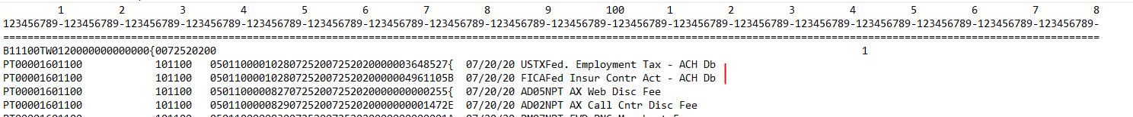

PT00001601100 101100 050110000102807252007252020000003648527{ 07/20/20 USTXFed. Employment Tax - ACH Db

GEAC Mapping | Position | Value | Comment
Transaction code | 1-2 | PT
Item | 3-6 | 0000 | Default value is “0000”
Trans ID | 7 | 1 | Default value is “1”
DRCR code | 8-9 | 60 | This is the credit or debit code.  10 = normal debit  11 = adjusting debit  60 = normal credit  61 = adjusting credit
Company ID | 10-13 | 1100 | Will be saved in the FinanceDimension1 fields since CSF will have only one company
Account | 26-31 | 101100
Mgmt Center | 35-39 | 05011 | Management centre (5 digits)
Cost Center | 40-43 | 0000 | Cost centre (4 digits)
Source code | 44-47 | 1028 | This is what we refer to as the journal number which is what  GL uses to identify the type of journal and where the journal came from.  File Attached below.  This can be mapped to JournalCode on the GLTransactionInterface business class
Source date | 48-53 | 072520 | YYYYMMDD format to CSF
Effective date | 54-61 | 07252020 | YYYYMMDD format to CSF
Amount | 62-74 | 000003648527{ | Would need conversion. Kindly see translation table below.
Description | 75-180 | 07/20/20 USTXFed. Employment Tax - ACH Db
FUND/SERIAL | 130-138 | 006319999 | fund and serial information for company 4000, 5000 and 6000

GEAC Source Code file

Source Code from GEAC is attached for reference.

Amount Conversion table
The last character mapping of the amount field is as below
Character | Value
{ | +0
A | +1
B | +2
C | +3
D | +4
E | +5
F | +6
G | +7
H | +8
I | +9
} | -0
J | -1
K | -2
L | -3
M | -4
N | -5
O | -6
P | -7
Q | -8
R | -9

Trailer
Trailer Record is present at end of the batch. It starts with BT

BT1100TW01200000245872723

GEAC Mapping | Position | Value | Comment
Transaction code | Pos 1 - 2 'BT' | BT
Company ID | Pos 3 - 6 | 1100 | Ok - this will now be CSF FinDim1 (only one company in CSF).
Application area | Pos 7 - 8 | TW | This identifies where the journal file came from, but this information is not in GL.
Batch number | Pos 9 - 10 | 01
Data Type code | Pos 11 - 11 | 2 | This is always 2
Batch total | Pos 12 - 25 | 00000245872723 | Why does the amount not have the special character at the end? Total is not always provided. Some system feed does not provide total. I believe the Trailer line is dropped by the GEAC process and system does it's own total and checks for balances.

GEAC to CSF Mapping translation
- Shown below are the translations from the GEAC file layout to the CSF GLTransactioInterface layout for the Header, Details, and Trailer.

Header
We can use Run-group from header
B11100TW0120000000000000{0072520200

GEAC Mapping | Position | Value | CSF Mapping  (GLTransactionInterface)
Transaction code | 1-2 | B1 or BH | GLTransactionInterface.RunGroup  Part value can be used as Run Group
Company ID | 3-6 | 1100 | FinanceDimension1
Application area | 7-8 | TW
Batch number | 9-10 | 01
Data Type code | 11 | 2
Batch total | 12-25 | 0000000000000{
Closed for Adjustment indicator | 26 | 0
Effective date | 27-34 | 07252020

Detail

PT00001601100 101100 050110000102807252007252020000003648527{ 07/20/20 USTXFed. Employment Tax - ACH Db

GEAC Mapping | Position | Value | CSF Mapping  (GLTransactionInterface)
Transaction code | 1-2 | PT
Item | 3-6 | 0000
Trans ID | 7 | 1
DRCR code | 8-9 | 60 | Will be used for computation of amount  DRCR code is 60/61, we multiply it to -1 if it is a positive amount. Otherwise we keep it as is  DRCR code is 10/11, we do the other way around of multiplying it to -1 if it is a negative amount.
Company ID | 10-13 | 1100 | FinanceDimension1
Account | 26-31 | 101100 | AccountCode
Mgmt Center | 35-39 | 05011 | FinanceDimension3
Cost Center | 40-43 | 0000 | FinanceDimension4
Source code | 44-47 | 1028 | JournalCode
Source date | 48-53 | 072520 | YYYYMMDD format to CSF
Effective date | 54-61 | 07252020 | PostingDate (YYYYMMDD format for CSF)
Amount | 62-74 | 000003648527{ | TransactionAmount
Description | 75-180 | 07/20/20 USTXFed. Employment Tax - ACH Db | Description
FUND/SERIAL | 130-138 | 006319999 | Project  (fund and serial information for FinDIm1 4000, 5000 and 6000)

Processing in CSF
The GLTransactionInterface screen in CSF/FSM is as below, the fields highlighted in yellow are needed for a basic GL transaction.
Transaction Amounts or Units can be selected depending on the type of transaction.
Similarly, the Auto-Reverse flag and the Auto-Reverse date can be entered based on the transaction.
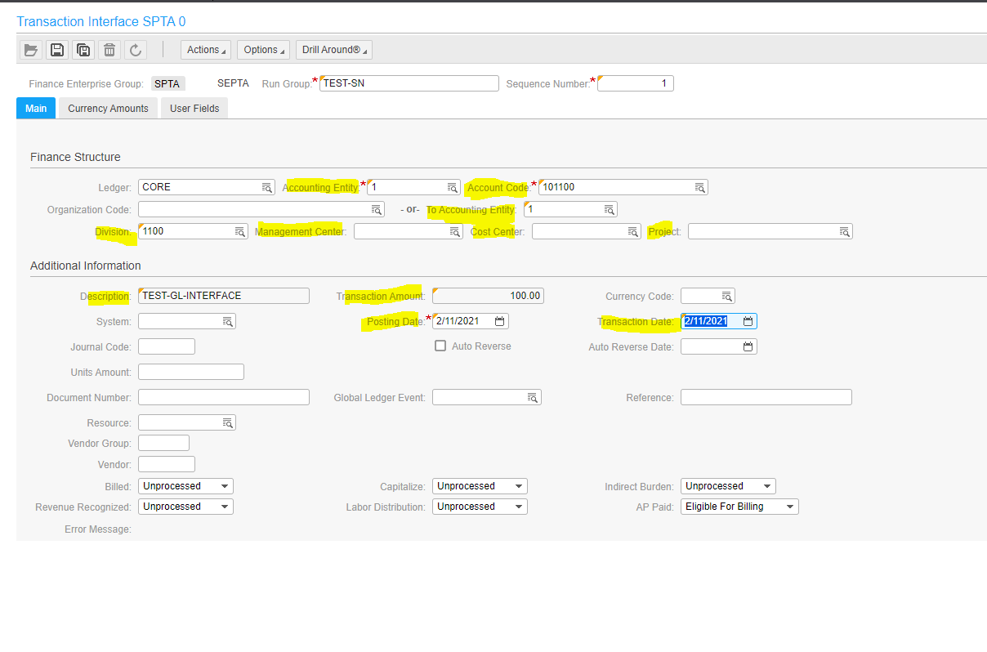
Once the transaction is saved, if the system is not specified it will default to “GL”, similarly the Global Ledger Event if not specified will default to “JE” and currency code will default to “USD”
The Journal Code field from the above screen will also be used to enter the journal/source code from the current GL-GEAC file.
Note: SEPTA doesn’t process transaction is foreign currency.
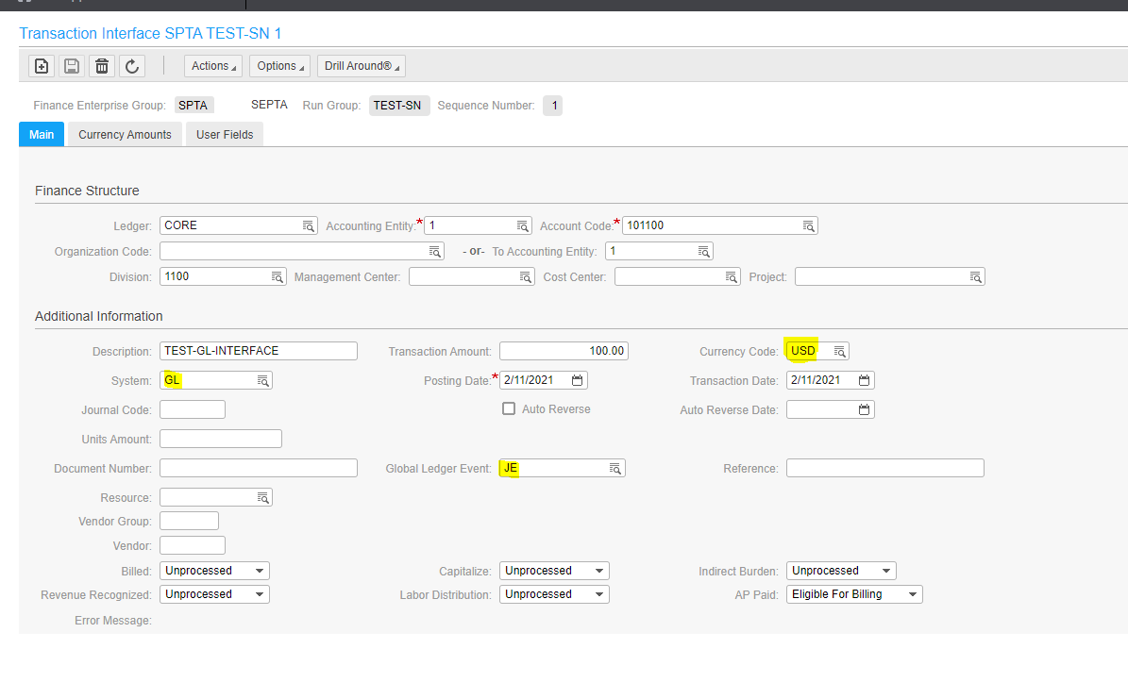

Once the transactions are in the GLTransactionInterface business class, the maintenance screen will show the details as below.
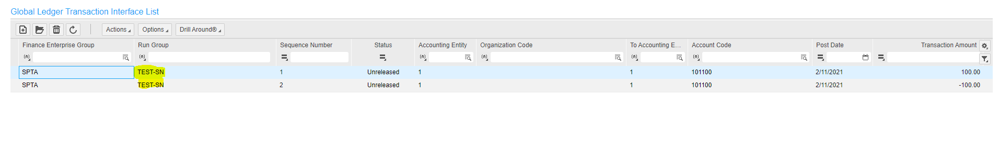

The run group will then be used to interface the data from GLTransactionInterface business class to GL journals.

The current vendors will also have to make a note of the below change.
- In FSM, SEPTA will have only one company/Accounting Entity which is 1
- SEPTA’s current GEAC companies are now marked as FinanceDimension1 in FSM now known as Division
- Management Center is now mapped to FinanceDimension3
- Cost Center is now mapped to FinanceDimension4
At a high level:
Interface to create an error file with list of error, to delete the entries that were added from the respective file and email the client
CSV File from vendor to be stored on SFTP directory
CSF File Channel to pick the file from SFTP directory for processing
Interface to validate the file
Pass
/Fail
FAIL
PASS
Interface job to run to process the transaction from GLTransactionInterface business class to GL journals

Interface to move the records from the file to GLTransactionInterface business class

Data / Export Overview
The data needed will be exported on a [frequency] basis from [origination] to [destination].
Depending on the frequency the internal and external vendors data will be exported the in the CSV format to an FTP server (details below). An Infor Process Automation (IPA) will be developed to generate the needed data and any associated logic.
[Add anything specific to SEPTA day to day operations and procedures that is related to this interface]

Below is the FSM format for GL interface file, the layout is as below.

Business Class Field Name | Type | Size | Required | Remarks | Description
FinanceEnterpriseGroup | AlphaUpper | 4 | Required | Key Field | The Finance Enterprise Group for the transaction  Default value is “SPTA”
GLTransactionInterface.RunGroup | AlphaUpper | 30 | Required | Key Field | A user-defined unique identifier used to group together a set of records to process selectively or concurrently.  Example: “TW20200301”
GLTransactionInterface.SequenceNumber |  | 12 | Required | Key Field | A user-defined unique identifier assigned to each transaction to be transferred into the CSF system. If all other key fields are alike, this may be used so that no duplicates will occur.  Example: “1” – no specific order required
AccountingEntity | AlphaUpper | 12 | Required | Key Field | This is the accounting entity that is originating the entry.  Default value is “1”
Status | Numeric | 1 |  | 0-Unreleased  1-Error  2-Budget Edit | Load them all as 0 - Unreleased
OrganizationCode | AlphaUpper | 40 |  |  | An optional user-defined field that contains the CSF Accounting Entity and accounting unit. This field determines what accounting entity and accounting unit a record will convert to.
ToAccountingEntity | AlphaUpper | 12 |  |  | The to accounting entity the transaction will post to  Default value is “1”
AccountCode | AlphaUpper | 26 | Required | Key Field | This field can be used 2 ways - one is as a user-defined field that will crosswalk the account to the CSF account. It can also be the actual account to be posted to.  It can be mapped directly to CSF accounts
GeneralLedgerEvent | AlphaUpper | 15 |  |  | Used to indicate where the transaction was created.  “JE” will default if this field is left blank.
JournalCode | AlphaUpper | 6
TransactionDate | Date |  |  | YYYYMMDD
Reference | Alpha | 40 |  |  | The reference number associated with the transaction.
Description | Alpha | 60 |  |  | User-defined description of the transaction record
CurrencyCode | AlphaUpper | 5 |  |  | User-defined currency code used if the transaction is not in the accounting entity's base currency.
UnitsAmount | Decimal | 18.2 |  |  | Contains the transaction units amount.
TransactionAmount | Decimal | 19.3 |  |  | Transaction Amount (positive or negative) in currency to be posted
System | AlphaUpper | 2 |  |  | A two-character code representing an application used within the CSF system (for example, GL=Global Ledger, AP=Payables).  “GL” will default if left blank
AutoReverse | Boolean |  |  |  | Auto reversal is the process of reversing the transaction. If you select auto reverse, Period Closing (GL199) creates a reversing journal entry in the next period for this transaction.
PostingDate | Date |  | Required | YYYYMMDD  KeyField | This date, assigned to the journal entry, determines what period and year the transaction (journal entry) will reside in after completing the Transaction Conversion process.
Project | AlphaUpper | 25 |  |  | The project the transaction will post to
FinanceDimension1 | AlphaUpper | 15 |  |  | DIVISON
FinanceDimension3 | AlphaUpper | 15 |  |  | Management Center
FinanceDimension4 | AlphaUpper | 15 |  |  | Cost Center
FinanceDimension2 | AlphaUpper | 15 |  |  | Extra Finance Dimension
FinanceDimension5 | AlphaUpper | 15 |  |  | Extra Finance Dimension
FinanceDimension6 | AlphaUpper | 15 |  |  | Extra Finance Dimension
FinanceDimension7 | AlphaUpper | 15 |  |  | Extra Finance Dimension
FinanceDimension8 | AlphaUpper | 15 |  |  | Extra Finance Dimension
FinanceDimension9 | AlphaUpper | 15 |  |  | Extra Finance Dimension
FinanceDimension10 | AlphaUpper | 15 |  |  | Extra Finance Dimension
Ledger | Alpha | 20 |  |  | The core ledger will default if an alternative ledger is not selected
DocumentNumber | Alpha | 30 |  |  | A reference field used for sub-system journaling by document. If the company you are converting to is journaling by document, this field will be used to determine where to batch a new journal entry.
ErrorMessage | Alpha Lower | 150 |  |  | System Generated
AutoReverseDate | Date |  |  |  | If the transaction is auto reversing, enter the date the reverse should occur. If this field is left blank, it will reverse the next month.
Resource | Numeric | 13 |  |  | If a recourse is assigned to this transaction, enter it here.
VendorGroupAndVendor.VendorGroup | AlphaUpper | 5 |  |  | If a vendor is to be attached to the transaction, the vendor group for the vendor needs to be entered here
VendorGroupAndVendor.Vendor | Numeric | 9 |  |  | If a vendor is to be attached to the transaction, enter the vendor number here
Billed | Numeric | 1 |  | 0-Unprocessed  1-Invoiced  3-Processed  4-Distributed | If the transaction is to be billed, enter the status of the billing. Will default to Unprocessed if left blank
RevenueRecognized | Numeric | 1 |  | 0-No  1-Yes  2-Hold | If the transaction is to have the revenue recognized, enter the status of the revenue recognition. Will defualt to No if left blank
Capitalize | Numeric | 1 |  | 0-Unprocessed  1-Processed | If the transaction is to be capitalized, enter the status.
LaborDistribution | Numeric | 1 |  | 0-Unprocessed  1-Processed  2-Distributed | If the labor will be distributed, enter the status.
SenderLogicalID | System |  |  |  | System Generated
SenderComponentID | System |  |  |  | System Generated
SenderCreationDateTime | System |  |  |  | System Generated
SenderBODID | System |  |  |  | System Generated
SenderOriginalBOD | System |  |  |  | System Generated
APPaid | AlphaUpper | 1
OriginatingTransaction.BusinessClassName | Alpha Lower | 200
OriginatingTransaction.BusinessObjectKey | Unique ID | 36
DrillBackLink | Alpha Lower | 500
IndirectBurden | Numeric | 1 |  | 0=Unprocessed  1=Draft  2=Processed
Comment | Text | 1
Company | Alpha Lower | 5
EmployeeNumber | Numeric | 5
HROrg | Alpha Lower | 5
LookupID | AlphaUpper | 25

Technical Solution Design
This section will refer to the automation of GLTransactionInterface Import in processing the details sent by the third-party vendors into CSF. The solution will comprise of two separate process flows wherein one will be focusing on the translation of the GEAC format input files to the CSF format and a second interface that will interface the records to CSF. Providing two process flows will help accommodate future vendors who will be conforming to the CSF format by allowing their files to be directly read by the automated interface process flow and bypassing the translation process.
The solution design will automate the process of picking the inbound file from the designated SFTP directory and importing the records into CSF staging business class for GL Transactions. The process includes running of the CSF interface job depending on the update option provided. On top of the GL Transaction Interface, when interface errors are encountered, all data from the Run Group will be deleted. Details for uninterfaced records will be sent to the user/s via email.

Process Flow Design

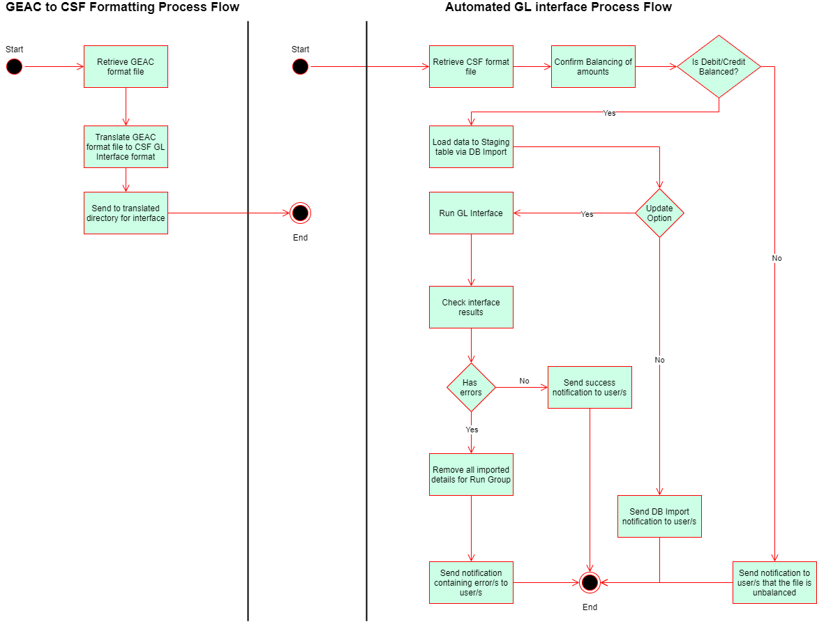
Note: This is the overall flow structure. Additonal sections maybe added during development.

Email notifications will be sent for:
- Successful DBImport
- Failed with DBImport
- Successful Interface Run
- Failed Interface Run

File Location
Folders are created within the SFTP repository on each tenant for specific purposes outlined below:
 | Description | Value
GEAC file formatted Folder | Inbound driectory for GEAC formatted files. | /Inbound/Upload/GEAC
CSF file formatted Folder | Inbound directory for CSF formatted files. | /Inbound/Upload/
Archive Folder | Archive directory for inbound files | /Inbound/Upload/Archive

System Configuration
The configuration set will contain the relevant connection points, directory structure related to the interfaces.

Navigation: Process Server Administrator > Configuration > System Configuration > Interface
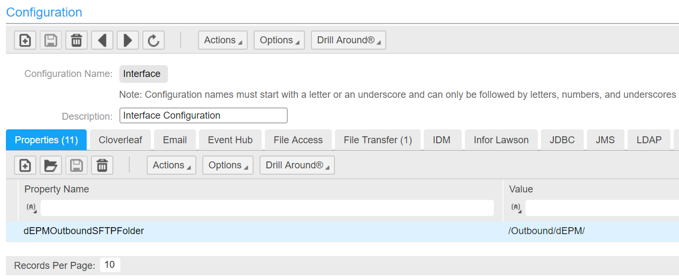
Property Name | Description | Value
GLTransactionInterface_EmailTo | Email notification recipient/s | TBA
GLTransactionInterface_UpdateOption | Flag to determine if we run the GL interface or not. Default value will be Y | Y/N
GLTransactionInterface_FEG | Finance Enterprise Group to be used for interfacing records in the GL Transaction Interface staging table | SPTA
GLTransactionInterface_JournalizeByEntity | Interface parameter for Journalizing lines per entity | TBA
GLTransactionInterface_BypassOrgCode | Interface Parameter when bypassing organization codes | TBA
GLTransactionInterface_BypassAccountCode | Interface Parameter | TBA
GLTransactionInterface_CurrencyTable | Interface Parameter | TBA
GLTransactionInterface_NegativeRateEdit | Interface Parameter | TBA
GLTransactionInterface_StructureRelationEdit | Interface Parameter | TBA
GLTransactionInterface_InterfaceByDetail | Interface Parameter | TBA
GLTransactionInterface_ByJournalCode | Interface Parameter | TBA
GLTransactionInterface_MoveErrorToRunGroup | Interface Parameter | TBA
GLTransactionInterface_EditAndInterface | Interface Parameter | TBA
GLTransactionInterface_PartialUpdate | Interface Parameter | TBA
GLTransactionInterface_Conversion_AccountingEntity | Accounting entity for the inbound records | TBA
GLTransactionInterface_Conversion_ ToAccountingEntity | ToAccounting entity for the inbound records | TBA
<Can be updated during development>

File Transfer Connection
Define the file transfer connection for each tenant.
Tenant | SFTP Host | Port | User ID
PRD | SFTP.inforcloudsuite.com | 22 | TBA
TST | SFTP.inforcloudsuite.com | 22 | TBA
TRN | SFTP.inforcloudsuite.com | 22 | TBA

Schedule
File scanning and interface run will be scheduled through the File Channel Setup

File Channel Setup
Channel Name | GLTransactionInterface
Description | File Channel for GL Transaction InboundInterface
Enabled | Yes
File Channel Type | Remote
Source File Directory | /Inbound/Upload
File Match Case Sensitivity | Enforce Case
Error File Directory | /ErrorFile
In-Progress Directory | /InProgress
File Scan Interval Time in Minutes | 10 Minutes

File Channel Receiver Setup (Translation Process Flow)
Channel Name | GLTransactionInterface
Receiver | GLTransactionImport_Translation
Description | GEAC to CSF file format translation
File Name | TBA
Ignore Delete Errors | No
Process | <Custom GL Transaction Import Process Flow for translation>
Data | Filename
Startup type | Automatic

File Channel Receiver Setup (Automated GL Interface Process Flow)
Channel Name | GLTransactionInterface
Receiver | GLTransactionImport_AutomatedImport
Description | Automated GL Transaction Interface for CSF Format files
File Name | TBA
Ignore Delete Errors | No
Process | <Custom GL Transaction Automated Import Process Flow>
Data | Filename
Startup type | Automatic

Please take note that the File Channel can only accommodate files up to 20MB in size.

File Details
[Below are the values to be added to this section. Please update all to reflect same for this specific SEPTA interface]
The following are details needed for the IPA and the associated generated file.
File Type: txt file.
File Extension: .txt
Maximum Allowable File Size: 20 MB
File Name: TBA.
File Location: SFTP File Directories
File Channel Scanning Frequency: Daily (can be updated)

